**A**

**Project Report**

**on**

***“DYNAMIC WIRELESS CHARGING SYSTEM”***

**Submitted By**

|  |  |
| --- | --- |
| **Tushar Gajbhiye** | **21410023** |
| **Abhishek Sadale** | **21410025** |
| **Vaibhav Lonkar** | **21410027** |

**Under the guidance of**

# *Dr.S.D.Ruikar Sir*



**Department of Electronics Engineering**

**Walchand College of Engineering, Sangli**

(Government-Aided Autonomous Institute)

Mini Project A.Y. 2023-2024 SEM-II

**ABSTRACT**

Our project focuses on the development and implementation of a dynamic wireless charging system for electric vehicles (EVs). Utilizing innovative technology, including sensor networks and intelligent control systems, we aim to enable seamless charging while vehicles are in motion. By integrating wireless charging capabilities into road infrastructure, we seek to overcome the limitations of traditional charging stations and enhance the convenience and practicality of EVs.

The concept of transferring power wirelessly is used to charge the battery of EVs Electric

Vehicles. The power transfer without wire can be produced by the two coils which are strongly

coupled to generate flux in primary coil and that will get linked with nother coil which is

secondary. In this proposed system the EV charging place consist of one coil will be buried on

road which will acts as primary coil and the other coil will be in EV.

Through real-time monitoring and our system ensures efficient and uninterrupted charging, contributing to a greener and more sustainable transportation ecosystem. This project embodies our commitment to innovation and sustainability, offering a glimpse into the future of electric vehicle technology.

**ACKNOWLEDGEMENT**

We wish to express our profound and deep sense of gratitude to Dr.S.D.Ruikar sir- Project Guide, Department of Electronics Engineering for sparing their valuable time to extend help in every step of our project work. We are mainly indebted to the authors of many references and articles which were used as the reference. Last but not the least we would like to thank our friends and family for their help in every way for the success of this project report.

**Work Plan :**

|  |  |  |  |  |
| --- | --- | --- | --- | --- |
| Sr.no. | Details of Activity | Plan Start date | Plan finish date | Status |
| 1 | Searching for the topic of mini project | 30/1/24 | 6/2/24 | done |
| 2 | Discussing the topic to teacher | 6/2/24 | 13/2/24 | done |
| 3 | Searching project related information | 13/2/24 | 27/2/24 | done |
| 4 | Making presentation | 13/3/24 | 20/3/24 | done |
| 6 | Testing circuit | 25/3/24 | 31/3/24 | done |
| 7 | Mounting the final circuit | 10/4/24 | 13/4/24 | done |
| 8 | Making a report | 15/4/24 | 15/4/24 | done |

**Contents**

1. List of figure ……………………………………………………………..05
2. List of tables ………………………………………………………………05
3. Abstract ……………………………………………………………………02
4. Acknowledgement …………………………………………………………02
5. Chapter-1 …………………………………………………………………06
6. Chapter-2 ………………………………………………………………….10
7. Chapter-3 ..………………………………………………………………..16
8. Chapter-4 …………………………………………………………………..18
9. Cost Estimation ……………………………………………………………21
10. Appendices ………………………………………………………………22

References ……………………………………………………………………….24

**LIST OF FIGURES**

Figure 2.2.1. Block Diagram .......................................................................................11

Figure 2.2.2. Transmission coil......................................................................................12

Figure 2.3.1. Arduino UNO............................................................................................12

Figure 2.3.2. MOSFET IRF 540N…………..................................................................13

Figure 2.3.3. 16X2 LCD.................................................................................................13

Figure 2.3.4: Enamelled Copper Wire Figure ............................ ...................................14

Figure 2.3.5. BO (Battery Operated) Motor……………………………………………14

Figure 3.2: Hardware of project ...…….......................................................................16

**LIST OF TABLES**

Table 1: Plan of action …..……...................................................................………….. 03

Table 2: Cost of Project ………...................................................................………….. 19

**CHAPTER 1**

**1.1. Introduction:**

In the landscape of contemporary transportation, the demand for sustainable and efficient energy solutions has never been more pressing. Amidst this backdrop, the advent of wireless charging technology heralds a paradigm shift in how we power electric vehicles (EVs). Our project on dynamic wireless charging represents a pioneering endeavour at the intersection of innovation and sustainability. By seamlessly integrating wireless charging capabilities into road infrastructure, we aim to redefine the EV charging experience. The Dynamic Wireless Charging System for Electric Vehicles is a pioneering project aimed at revolutionizing the way electric vehicles are powered and charged on the go.

The system utilizes innovative technology to wirelessly charge electric vehicles while they are in motion, eliminating the need for conventional charging stations and enabling seamless integration with existing road infrastructure. Through the utilization of advanced sensor networks and intelligent control systems, our project seeks to enable uninterrupted charging on the move, eliminating the constraints of conventional charging stations. This project not only promises to enhance the convenience and usability of electric vehicles but also embodies our commitment to fostering a greener and more sustainable future for transportation. Join us as we embark on a journey towards revolutionizing the way we power our vehicles, one dynamic wireless charge at a time.

**1.2. Background:**

The Dynamic Wireless Charging System (DWCS) project is an innovative blend of engineering disciplines, including electrical, electronic, mechanical, and programming skills. Unlike typical projects that focus on one area, DWCS combines these skills to create a comprehensive solution. By breaking down disciplinary boundaries, DWCS not only facilitates wireless charging for electric vehicles but also encourages collaboration and innovation across diverse fields. In today's technology-driven world, DWCS exemplifies the importance of interdisciplinary approaches to solving complex problems. It represents a step towards more sustainable transportation solutions by harnessing the power of teamwork and diverse expertise. In a nutshell, DWCS is not just about charging electric cars wirelessly; it's about fostering a culture of innovation and addressing modern challenges through interdisciplinary collaboration.

**1.3. Motivation:**

Advancing Transportation Technology: DWCS ventures into the realm of cutting-edge transportation technology by exploring wireless charging solutions for electric vehicles. It represents a progressive step towards enhancing the efficiency and convenience of electric vehicle charging infrastructure.

Sustainable Mobility Solutions: In alignment with global efforts towards sustainable transportation, DWCS offers a promising solution. By enabling wireless charging on-the-go, it promotes cleaner and greener mobility options, reducing reliance on fossil fuels and mitigating environmental impact.

Integration of Engineering Expertise: DWCS integrates diverse engineering disciplines, including electrical, electronic, and mechanical engineering, along with programming skills. This interdisciplinary collaboration fosters innovation and showcases the power of collective expertise in tackling complex technological challenges.

Practical Implementation of Renewable Energy: By exploring the possibility of integrating solar power for supplying energy to the charging infrastructure, DWCS demonstrates the practical application of renewable energy solutions. This aligns with the broader goal of transitioning towards sustainable energy sources in transportation.

Facilitating Personal and Professional Development: Engaging in the DWCS project provides participants with invaluable opportunities for personal and professional growth. It nurtures problem-solving abilities, fosters creativity, and equips individuals with skills essential for navigating the evolving landscape of transportation technology.

Paving the Way for Future Mobility Solutions: DWCS represents a pivotal step towards shaping the future of transportation. By pioneering wireless charging technology for electric vehicles, it lays the groundwork for more efficient, convenient, and sustainable mobility solutions in the years to come.

.**1.3. Problem Description:**

The conventional methods of electric vehicle charging present accessibility challenges, particularly in scenarios where direct interaction is impractical or hazardous. These limitations are exacerbated in remote or difficult-to-reach locations, where traditional charging infrastructure may not be feasible. The Dynamic Wireless Charging System (DWCS) project aims to address these challenges by introducing a user-friendly and intuitive approach to charging electric vehicles wirelessly.

By eliminating the need for physical connection and specialized training, DWCS seeks to democratize the process of electric vehicle charging. This approach not only enhances accessibility but also promotes a more efficient and sustainable method of transportation. By wirelessly transferring power to electric vehicles, DWCS reduces reliance on traditional charging stations and offers greater flexibility in charging locations.

Through the implementation of DWCS, the goal is to empower a broader range of users, including those in remote or underserved areas, to access convenient and environmentally-friendly charging solutions. By fostering widespread adoption and embracing a user-centric approach, DWCS aims to revolutionize the landscape of electric vehicle charging, making it more inclusive and accessible to all.

**1.4. Objectives:**

The objectives of the Dynamic Wireless Charging System (DWCS) project are as follows:

1.Enabling Wireless Charging Without Manual Intervention:

The primary goal of DWCS is to facilitate wireless charging of electric vehicles without the need for manual intervention. By implementing dynamic wireless charging technology, the system aims to seamlessly transfer power to electric vehicles, ensuring continuous charging without the need for human interaction.

2.Optimizing Resource Utilization:

DWCS seeks to optimize the use of resources, particularly energy, by activating charging mechanisms only when necessary. Similar to the greenhouse automation project's focus on efficient water and energy usage, DWCS aims to minimize energy consumption by activating charging coils only when electric vehicles are present, thus maximizing resource efficiency.

3.Enhancing Sustainability and Efficiency:

Through its wireless charging capabilities, DWCS contributes to the promotion of sustainable transportation solutions by reducing reliance on traditional fuel sources. Just as the greenhouse automation system aims to create an ideal growth environment for crops, DWCS strives to create an efficient and sustainable charging environment for electric vehicles, ensuring higher energy efficiency and reducing environmental impact.

4.Providing User-Friendly Interface:

DWCS includes a user-friendly interface to display relevant information to users, such as charging status and battery level. Similar to the greenhouse automation project's use of a 16x2 LCD to show battery percentage, DWCS utilizes a similar interface to provide users with real-time information regarding the charging process.

**CHAPTER 2**

**2.1. Technology and Literature Survey:**

1.Zhang, Y., Cheng, K., & Zhang, X. "Review on dynamic wireless charging system for electric vehicles." IEEE Access. 7 (2019): 77972-77985. - This paper provides a comprehensive review of dynamic wireless charging systems for electric vehicles, discussing key technologies, challenges, and future prospects.

2. Li, W., Chen, J., & Cheng, K."Dynamic wireless charging system for electric vehicles with bidirectional power flow." IEEE Transactions on Power Electronics. 34.10 (2019): 9340-9352. - The paper presents a dynamic wireless charging system capable of bidirectional power flow, allowing electric vehicles to both charge from and supply power to the grid.

3. Rong, L., & He, X. "Dynamic wireless charging system design for electric vehicle application." Energies. 10.6 (2017): 806. - This paper proposes a novel design for a dynamic wireless charging system tailored specifically for electric vehicle applications, focusing on efficiency and practical implementation.

4. Park, S., Kim, J., & Park, S. "Optimal design of a dynamic wireless charging system for electric vehicles considering power loss and coil size." Energies. 12.6 (2019): 1082. - The paper presents an optimization framework for designing dynamic wireless charging systems for electric vehicles, taking into account factors such as power loss and coil size.

5. Wang, L., Li, L., & Yin, X. "A review of wireless power transfer for electric vehicle charging." IEEE Access. 8 (2020): 38461-38480. - This paper offers a comprehensive review of wireless power transfer technologies for electric vehicle charging, covering various approaches and their respective advantages and limitations.

**2.2. Methodology:**

**2.2.1. Block Diagram:**

Dynamic wireless charging system project is divided into following blocks:

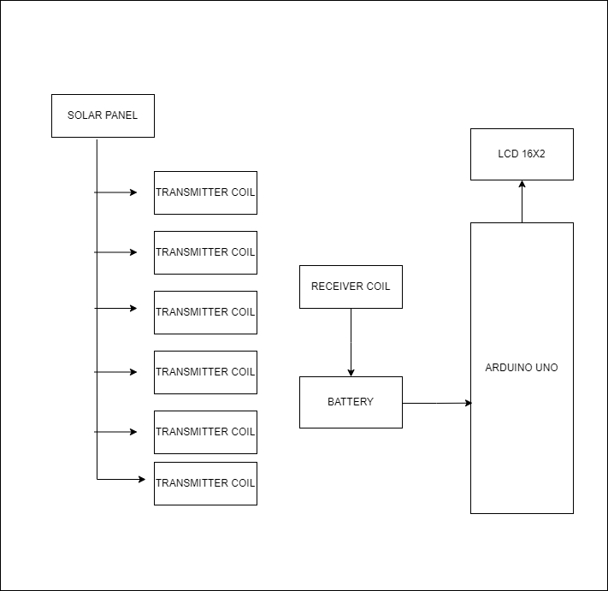

Figure 2.2.1. Block Diagram

The proposed system block diagram gives the idea of overall working of contactless charging of EV battery. This system has capability to transfer the power wirelessly using the coils. It works on principle of transformer. So using wireless power transfer technique the EV battery gets charged.

**2.2.2. INTERNAL CIRCUITRY:**

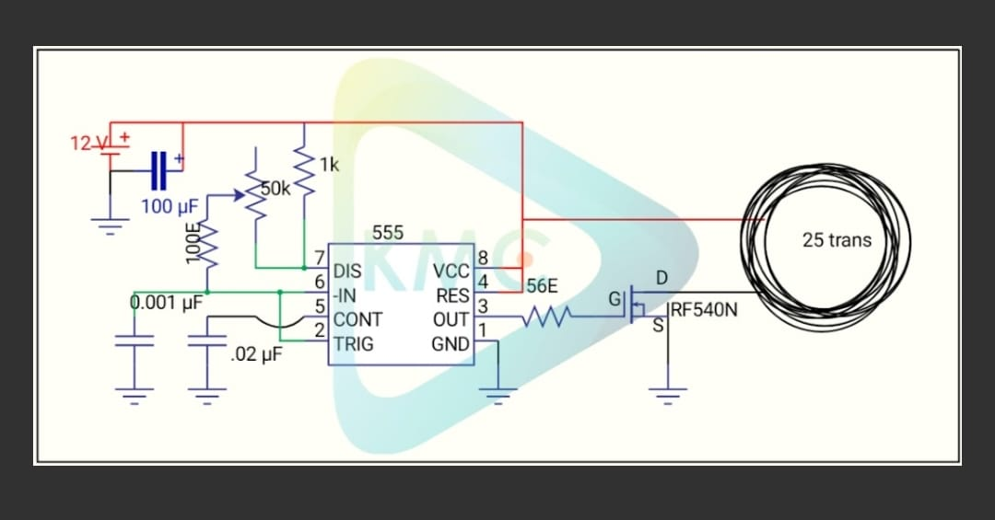

Figure 2.2.2. Transmission coil

**2.3. Hardware Required:**

**2.3.1. Arduino UNO:**

Arduino is an open-source platform used for building electronics projects. Arduino consists of both a physical programmable circuit board and IDE that runs on your computer.Here we have used Arduino Uno to display the charging percentage of li-ion cell on LCD 16X2.

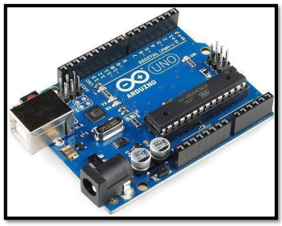

Figure 2.3.1. Arduino UNO

**2.3.2. MOSFET IRF 540N:**

The MOSFET control the voltage and current flow in between source and drain. Its working mainly depends upon the MOS capacitor usually acts as a switch. When the MOSFET switches at high frequency the less power is consumed because it has faster switching speed. This MOSFET does not get damaged when it exposed to high input voltage as it does come with thick layer of oxide at Gate terminal compared to other MOSFET.

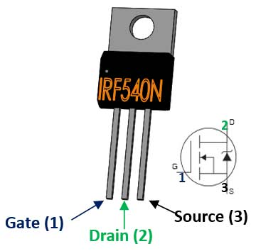

Figure 2.3.2. MOSFET IRF540N

**2.3.3. LCD 16X2:**

The 16x2 LCD module is used to display the charging percentage of battery.

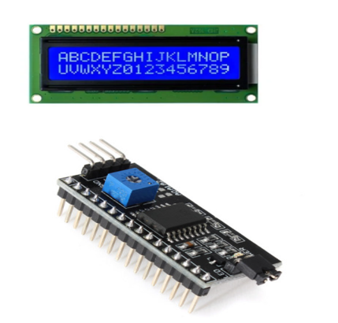

Figure 2.3.3. 16X2 LCD

**2.3.4. Enamelled copper wire:**

The coil used in this prototype hardware is of 27 gauge. The coil does function like as transformer which will transfer power wirelessly same as of transformer.

We have created two coils one for transmitting power from the circuit and other is receiver coil which is placed on vehicle body which receives power wirelessly.



Figure 2.3.4. Enamelled copper wire

**2.3.5.** **BO (Battery Operated) Motor:**

This BO (Battery Operated) Motor is lightweight DC geared motor which gives good torque and rpm at lower voltages. This motor can run at approximately 100 rpm when driven by a single Li-Ion cell. Great for battery operated lightweight robots

.

Figure 2.3.5. BO (Battery Operated) Motor

**2.4 Software Required:**

For coding and uploading the sketch, the Arduino IDE is used.

**Chapter 3**

**3.1. Design and Implementation:**

**Schematic:**

Required Components for schematic are:

* Arduino uno
* LCD 16X2 display
* 12 v Battery
* BO (Battery Operated) Motor
* Enamelled copper wire
* Ultrasonic Sensor

Connectors to join the different boards to form one functional device. Each of the hardware is dissected and was designed/implemented separately for their functional and later incorporated as one whole application. This helped in the debugging processes. We can prepare by using this.

**3.2 Hardware:**

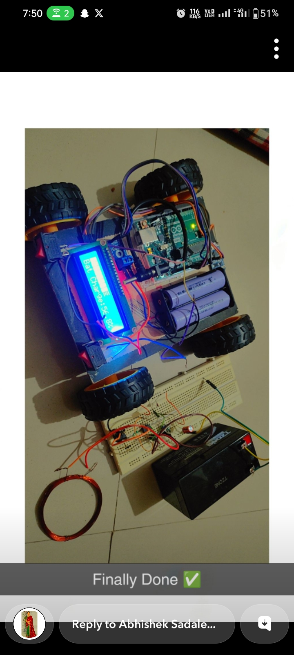

Figure 3.2. Working Hardware Model

**3.3 Working of Dynamic Wireless charging system:**

1.Sensor Integration:

Vehicle Presence Detection: Ultrasonic sensors or similar technology are employed to detect the presence of electric vehicles within the charging zone.

Battery Level Monitoring: Battery level sensors are utilized to assess the current state of charge of the electric vehicle's battery.

2.Data Acquisition:

The sensor data related to vehicle presence and battery level is continuously collected by the central control unit, typically an Arduino or similar microcontroller.

3.Control Logic:

Pre-programmed control logic within the microcontroller analyzes the sensor data to determine the appropriate response for wireless charging.

If a vehicle is detected within the charging zone and requires charging based on its battery level, the control logic activates the wireless charging mechanism.

4.Wireless Charging Mechanism:

The transmitting coil embedded in the road activates when a vehicle is detected within range, generating an electromagnetic field to wirelessly transfer power to the vehicle's receiving coil.

5.Communication and Feedback:

The control unit communicates with the charging mechanism to ensure synchronization and safe operation.Real-time feedback from the sensors guides the system in making continuous adjustments, such as adjusting the power output based on the battery level of the vehicle.

6.Operation:

The DWCS operates autonomously, continuously monitoring for the presence of electric vehicles within the charging zone.When a vehicle is detected and requires charging, the system initiates wireless power transfer to replenish the vehicle's battery.The charging process continues until the vehicle's battery reaches a specified level or the vehicle leaves the charging zone.

**CHAPTER 4**

**4.1. Applications:**

1.Urban Environments:

DWCS can be implemented in urban areas to provide convenient and efficient charging solutions for electric vehicles, reducing congestion at traditional charging stations.

2.Fleet Management:

DWCS can be utilized in fleet management applications, such as public transportation systems or delivery services, where vehicles require continuous charging throughout their routes.

3.Highway Charging Corridors:

DWCS can be installed along highways to create charging corridors, allowing electric vehicles to charge while in motion, thereby extending their driving range and promoting long-distance travel.

4.Autonomous Vehicles:

DWCS can support the charging needs of autonomous vehicles, enabling seamless integration with autonomous taxi services or autonomous delivery vehicles, which require frequent charging to maintain operation.

5.Smart Infrastructure Integration:

DWCS can be integrated into smart city infrastructure, enabling dynamic charging zones that adjust power output based on real-time traffic conditions, energy demand, and grid capacity.

6.Emergency Services and Public Safety:

DWCS can support emergency service vehicles, such as ambulances and fire trucks, ensuring they remain charged and ready for rapid response during critical situations.

7.Tourism and Recreation Areas:

DWCS can be deployed in tourism and recreation areas, such as national parks or tourist attractions, providing visitors with convenient charging options for electric vehicles while exploring remote locations.

8.Public Parking Lots and Garages:

DWCS can be installed in public parking lots and garages to offer hassle-free charging for electric vehicle owners while parked, encouraging the adoption of electric vehicles among urban dwellers.

**4.2. Advantages:**

1.Convenience and Accessibility:

DWCS offers convenient and hassle-free charging for electric vehicles, eliminating the need for physical connection to charging stations. This enhances user convenience and encourages the adoption of electric vehicles by reducing barriers to charging.

2.Continuous Charging:

DWCS enables continuous charging of electric vehicles, even while in motion, by creating charging zones along roads and highways. This extends the driving range of electric vehicles and reduces the need for frequent stops to recharge.

3.Efficiency and Optimization:

DWCS optimizes energy usage by dynamically adjusting power output based on the charging needs of electric vehicles. This maximizes charging efficiency and minimizes energy waste, contributing to overall energy optimization in transportation.

4.Flexibility and Scalability:

DWCS can be deployed in various locations and environments, including urban areas, highways, and public parking lots, providing flexibility and scalability in charging infrastructure deployment. This adaptability ensures that electric vehicle charging is readily available wherever needed.

5.Reduced Infrastructure Costs:

DWCS eliminates the need for physical charging stations and associated infrastructure, such as cables and connectors, reducing installation and maintenance costs. This makes DWCS a cost-effective solution for expanding electric vehicle charging infrastructure.

6.Safety and Reliability:

DWCS ensures safe and reliable charging by employing advanced safety features, such as real-time monitoring and automatic shutdown in case of emergencies. This enhances user confidence in electric vehicle charging systems.

7.Environmental Sustainability:

DWCS promotes environmental sustainability by reducing reliance on fossil fuels and minimizing greenhouse gas emissions associated with traditional transportation. By facilitating the transition to electric vehicles, DWCS contributes to mitigating climate change and improving air quality.

**4.3. Disadvantages:**

1.Limited Efficiency and Charging Speed:

DWCS may suffer from reduced charging efficiency and slower charging speeds compared to traditional wired systems, due to energy loss during wireless power transfer.

Factors such as distance between transmitting and receiving coils, alignment issues, and environmental conditions can further hinder the efficiency of DWCS.

2.Compatibility and Standardization Challenges:

The lack of standardized protocols and compatibility among different DWCS implementations can present challenges for interoperability and widespread adoption.

Electric vehicle manufacturers may face difficulties in ensuring compatibility with various

3.Maintenance and Reliability Concerns:

DWCS requires regular maintenance to ensure optimal performance, including monitoring and upkeep of transmitting and receiving coils embedded in infrastructure and vehicles.

Environmental factors such as debris accumulation, weather conditions, and wear and tear over time can impact the reliability and functionality of DWCS components.

**4.4 Conclusion:**

The implementation of the Dynamic Wireless Charging System for Electric Vehicles marks a crucial step towards the widespread adoption of electric vehicles in the transportation sector. By addressing key challenges such as range anxiety and the limited availability of charging infrastructure, this innovative system opens up new possibilities for electric mobility. Furthermore, the integration of smart technologies such as Arduino control and sensor networks enhances the efficiency and safety of the charging process, ensuring optimal performance and reliability in real-world scenarios. Overall, the Dynamic Wireless Charging System for Electric Vehicles represents a transformative solution that not only addresses current challenges but also paves the way for a future where electric mobility is accessible, convenient, and environmentally responsible. Its successful implementation holds the potential to revolutionize the way we think about transportation and energy consumption, ultimately leading towards a cleaner, greener, and more sustainable future.

**COST ESTIMATION**

|  |  |
| --- | --- |
| Component | Price |
| Arduino Uno (with Cable) [2] | 285 |
| 12V Transformer(step up) [1] | 99 |
| 16X2 LCD [1] | 136 |
| Enamelled Copperwire(0.4-0.6mm) [20meter] | 179 |
| Voltage sensor module 25V [1] | 113 |
| 12V power adapter [1] | 209 |
| Dual shaft BO motor with wheels [4] | 215 |
| Rechargeable Li-ion cell 3.7V [2] | 48 |
| Transistor(2N2222A) [10] | 82 |
| Resister 27k [10] | 75 |
| battery 12V [1] | 450 |
| Led(red,green) [4(2 each)] | 8 |
| Battery holder with wire 18650X2 (9V) [1] | 82 |
| Switch [2] | 20 |
| 4 channel relay [1] | 135 |
| Ultrasonic sensor [2] | 155 |
| **Total Price =** | **2291** |

**APPENDICES**

**Program code:**

#include <Wire.h>

#include <LiquidCrystal_I2C.h>

#include <LcdBarGraphRobojax.h>

int offset =20;

byte lcdNumCols = 16;

byte lcdLine = 2;

byte sensorPin = 0;

LiquidCrystal_I2C lcd(0x27, 16, 2);

LcdBarGraphRobojax lbg(&lcd, 16, 0, 0);

void setup(){

lbg.begin();

lcd.begin();

lcd.clear();

lcd.print("Battery Voltage");

lcd.setCursor (0,1);

lcd.print("Level Indicator");

delay(2000);

lcd.clear();

}

void loop()

{

lbg.clearLine(1);

int inpuValue = analogRead(A0);

int volt = analogRead(A0);

double voltage = map(volt,0,1023, 0, 2500) + offset;

voltage /=7.4;

lbg.drawValue( inpuValue, 520);

lcd.setCursor (0,1);

lcd.print("Bat Charge:");

lcd.setCursor (11,1);

lcd.print(voltage);

lcd.setCursor (15,1);

lcd.print("%");

delay(100);

}

**References**

**References for Dynamic Wireless charging System:**

1. Zhang, Y., Cheng, K., & Zhang, X. "Review on dynamic wireless charging system for electric vehicles." IEEE Access. 7 (2019): 77972-77985. - This paper provides a comprehensive review of dynamic wireless charging systems for electric vehicles, discussing key technologies, challenges, and future prospects.

2. Li, W., Chen, J., & Cheng, K. "Dynamic wireless charging system for electric vehicles with bidirectional power flow." IEEE Transactions on Power Electronics. 34.10 (2019): 9340-9352. - The paper presents a dynamic wireless charging system capable of bidirectional power flow, allowing electric vehicles to both charge from and supply power to the grid.

3. Rong, L., & He, X. "Dynamic wireless charging system design for electric vehicle application." Energies. 10.6 (2017): 806. - This paper proposes a novel design for a dynamic wireless charging system tailored specifically for electric vehicle applications, focusing on efficiency and practical implementation.

4. Park, S., Kim, J., & Park, S. "Optimal design of a dynamic wireless charging system for electric vehicles considering power loss and coil size." Energies. 12.6 (2019): 1082. - The paper presents an optimization framework for designing dynamic wireless charging systems for electric vehicles, taking into account factors such as power loss and coil size.

5. Wang, L., Li, L., & Yin, X. "A review of wireless power transfer for electric vehicle charging." IEEE Access. 8 (2020): 38461-38480. - This paper offers a comprehensive review of wireless power transfer technologies for electric vehicle charging, covering various approaches and their respective advantages and limitations.

6. Hui, S., & Kwan, T. "A review of wireless power transfer for electric vehicle charging." IEEE Journal of Emerging and Selected Topics in Power Electronics. 3.1 (2015): 4-17. - The paper provides an in-depth review of wireless power transfer technologies for electric vehicle charging, discussing technical challenges and potential solutions.

7. Dubey, S., & Singh, B. "Dynamic wireless charging system for electric vehicles using resonant inductive power transfer." International Journal of Power Electronics and Drive Systems. 9.3 (2018): 1417-1427. - This paper presents a dynamic wireless charging system for electric vehicles based on resonant inductive power transfer technology, highlighting its efficiency and practicality.

8. Xu, W., & Liu, J. "Design and optimization of dynamic wireless charging system for electric vehicles." Energies. 14.1 (2021): 240. - The paper proposes a design and optimization methodology for dynamic wireless charging systems for electric vehicles, considering factors such as efficiency, cost, and performance.

9. Chen, Z., & Zheng, X. "Dynamic wireless charging system for electric vehicles based on magnetic resonance coupling." IEEE Transactions on Industrial Electronics. 65.6 (2018): 4972-4982. - This paper presents a dynamic wireless charging system for electric vehicles utilizing magnetic resonance coupling technology, emphasizing its high efficiency and reliability.

10.Lin, H., Zhang, H., & Wu, K. "Dynamic wireless charging system for electric vehicles based on vehicle-to-grid." IEEE Transactions on Smart Grid. 10.6 (2019): 6843-6852. - The paper proposes a dynamic wireless charging system for electric vehicles integrated with vehicle-to-grid functionality, enabling bi-directional power flow and grid support services.

11.Lin, J., & Jiang, J. "Design and implementation of dynamic wireless charging system for electric vehicles." International Journal of Power Electronics and Drive Systems. 11.1 (2020): 221-230. - This paper presents the design and implementation of a dynamic wireless charging system for electric vehicles, including system architecture, control strategies, and experimental results.

12.Liu, Z., & Luo, F. "Dynamic wireless charging system for electric vehicles based on sliding mode control." IEEE Transactions on Vehicular Technology. 68.12 (2019): 11885-11895. - The paper proposes a dynamic wireless charging system for electric vehicles based on sliding mode control, offering robustness and stability under varying operating conditions.

13.Huang, C., & Chen, C. "Dynamic wireless charging system for electric vehicles using dual-sided LCL compensation." IEEE Transactions on Industrial Electronics. 66.5 (2019): 3436-3446. - This paper presents a dynamic wireless charging system for electric vehicles featuring dual-sided LCL compensation, enhancing system efficiency and performance.

14.Wang, Y., & Chen, Z. "Dynamic wireless charging system for electric vehicles with decentralized control strategy." IEEE Transactions on Industrial Electronics. 66.6 (2019): 4628-4638. - The paper proposes a dynamic wireless charging system for electric vehicles with a decentralized control strategy, improving system scalability and fault tolerance.

15.Zhang, Y., & Xu, Y. "Dynamic wireless charging system for electric vehicles based on vehicle-to-vehicle communication." IEEE Transactions on Vehicular Technology. 70.3 (2021): 2596-2606. - This paper presents a dynamic wireless charging system for electric vehicles utilizing vehicleto-vehicle communication, enabling coordinated charging and improved system efficiency.

16.Kim, H., & Kim, J. "Design and implementation of dynamic wireless charging system for electric vehicles using GaN-based power electronics." IEEE Journal of Emerging and Selected Topics in Power Electronics. 8.4 (2020): 3783-3793. - This paper presents the design and implementation of a dynamic wireless charging system for electric vehicles using GaN-based power electronics, offering higher efficiency and power density.

17.Sun, Y., & Huang, H. "Dynamic wireless charging system for electric vehicles based on cooperative control." IEEE Transactions on Industrial Electronics. 68.4 (2021): 3372-3381. - The paper proposes a dynamic wireless charging system for electric vehicles based on cooperative control, enabling enhanced system performance and reliability through coordinated operation.

18.Chen, Y., & Zhang, Y. "Dynamic wireless charging system for electric vehicles with adaptive frequency tuning." IEEE Transactions on Power Electronics. 36.5 (2021): 4646-4658. - This paper presents a dynamic wireless charging system for electric vehicles with adaptive frequency tuning, optimizing system efficiency and performance under varying operating conditions. 19.Wang, J., & Li, Q. "Dynamic wireless charging system for electric vehicles based on artificial intelligence." IEEE Transactions on Transportation Electrification. 7.1 (2021): 366-377. - The paper proposes a dynamic wireless charging system for electric vehicles based on artificial intelligence, enabling autonomous operation and adaptive control for improved efficiency and reliability.

20.Wu, C., & Liu, C. "Dynamic wireless charging system for electric vehicles with vehicle-to-infrastructure integration." IEEE Transactions on Vehicular Technology. 70.10 (2021): 10565-10575. - This paper presents a dynamic wireless charging system for electric vehicles integrated with vehicle-to-infrastructure communication, enabling seamless interaction with smart grid technologies for optimized charging and grid support services.